Experiment #6

Diode Characteristics, Diode Clipper, and Diode Clamper

EENG 275 - W01

Prepared for: M. Fakoor, Professor

New York Institute of Technology

Prepared by: V. Cavalcante, Student

Partnered with: B. Saks, Student

New York Institute of Technology

November 8th, 2019

**Experiment Objectives**

* Understand the voltage and current relationships of a forward-biased pn junction
* Measure the currents in a diode circuit
* Design and measure a diode clipper circuit
* Design and measure a diode clamper circuit

**Equipment Used**

1- NYIT supplied Lab Kit

1- Digital Multi-meter (DMM)

1- DC Power Supply

1- Function Generator

1- Oscilloscope

1- 51 Ω Resistor

1- 220 Ω Resistor

1- 680 Ω Resistor

1- 1 kΩ Resistor

1- 1N4001 Diode

2- 100 Ω Resistor

**Results**

**Circuit 6.1 Measurements:**

If = 90 mA

**Circuit 6.2 Measurements:**

Vin = 20pp (10 V)

Vout = 3.84 V

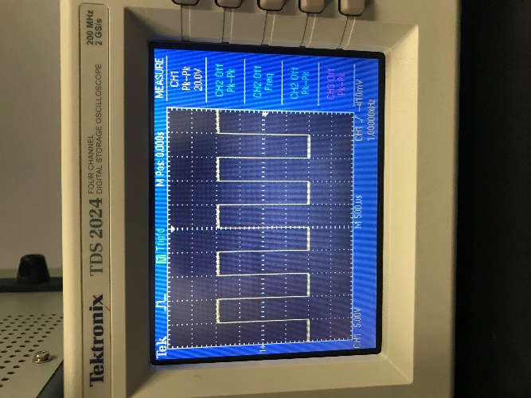

**Vin 6.2**

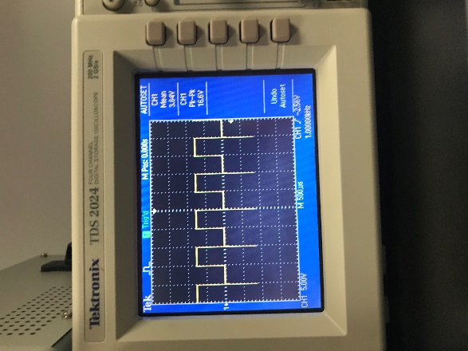

**Vout 6.2**

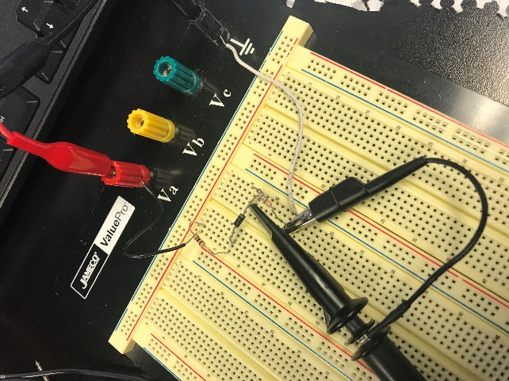

**Circuit for 6.2**

**Circuit 6.3 Measurements:**

Id = 8.08 A

Vd = 0.682 V

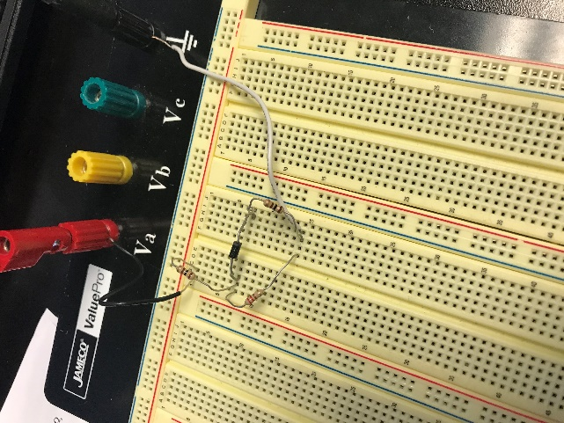

**Circuit for 6.3**

**Clipper Circuit Measurements:**

Circuit Min = -1.88V

Circuit Max = 3.0V

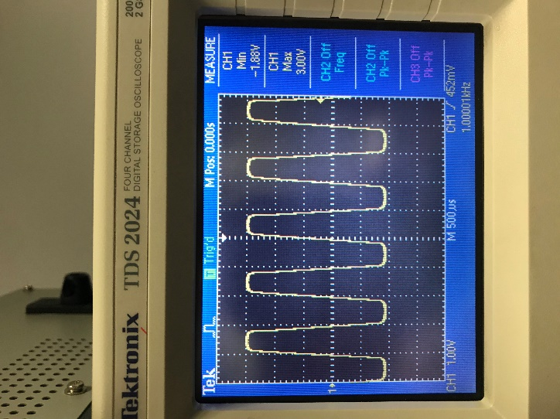

**Waveform Clipper**

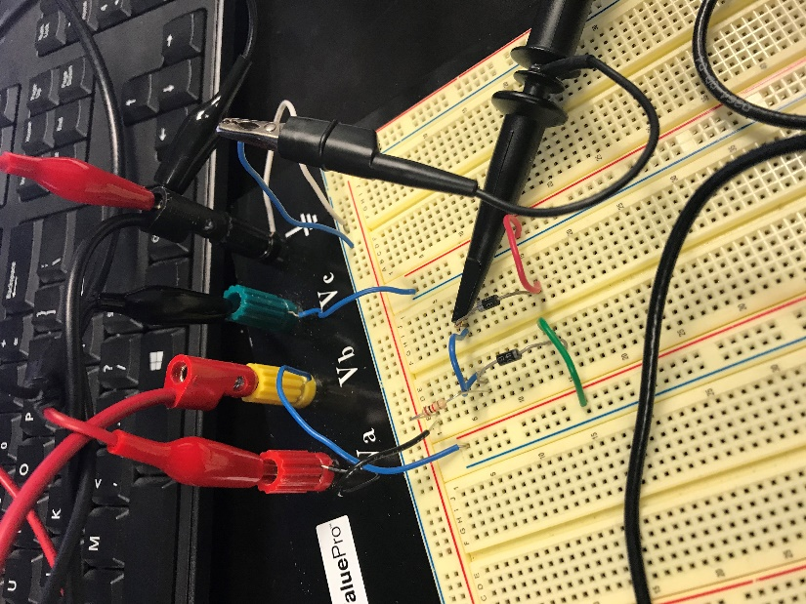

**Circuit for the Clipper**

**Clamper Circuit Measurements:**

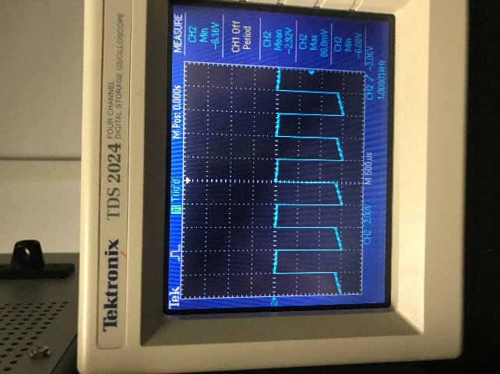

**Clamper Waveform**

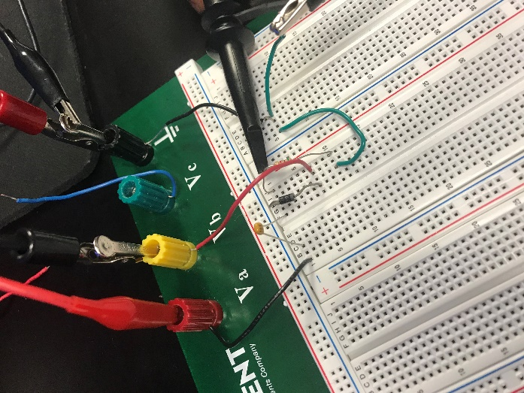

**Clamper Circuit**

**Conclusion**

* For both the clipper and clamper circuit there is a change in voltage source polarity.
* The purpose for the clipper circuit it is to clip the waveform to a specific limit
* The purpose of the clamper would be to limit the top and or bottom of the waveform